Instructions

Preamble
Welcome to this experiment. These instructions are to help you to understand what you are being asked to do during the experiment and how you will be paid. The experiment is simple and gives you the chance to earn a considerable amount of money, which will be paid to you in cash after you have completed the experiment. The payment described below is in addition to a participation fee of £2.50 that you will be paid independently of your answers.

The Experiment
The experiment is interested in your preferences under risk. There are no right or wrong answers. It is in four parts. Each of the four parts consists of a series of problems. At the end of all four parts, you will randomly select one of the four parts, then you will randomly select one of the problems on that part, and then you will play out that problem. This will lead to a payoff to you, and we shall pay this to you in cash, plus the participation fee of £2.50. How all this will be done will be explained below. We start by describing a generic lottery. Then we describe the four parts; you will not necessarily get them in the order that they are described here.

A Generic Lottery
We will represent each lottery visually and in words. The visual representation will be one of the following two forms.

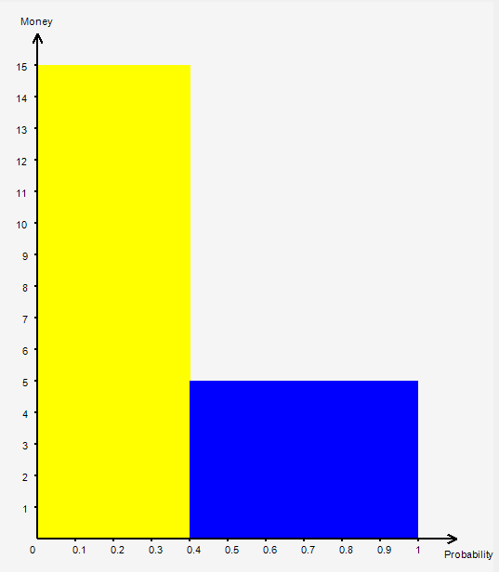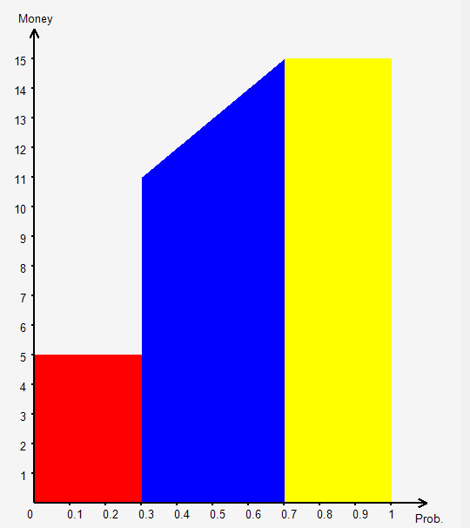
It is simplest to explain these in terms of the implications for your payment if one of these is chosen to be played out at the end of the experiment. What we will do in all cases is to ask you to generate a random number between 0 and 1 by you spinning a circular disk. This random number will determine a point on the horizontal axis; your payment would be the amount on the vertical axis implied by that point through the figure. So, for example, in the left-hand lottery, if the random number is between 0 and 0.4 you would get £15; if it is between 0.4 and 1.0 you would get £5. This implies that the probability of you getting £15 is 0.4 and the probability of you getting £5 is 0.6. This will also be written in words. In the right-hand lottery, if the random number was less than 0.3 you would get £5; if it were between 0.3 and 0.7 you would get between £11 and £15 the precise amount depending upon the random number; if it was between 0.7 and 1.0 you would get £15. We show examples in the figures below.

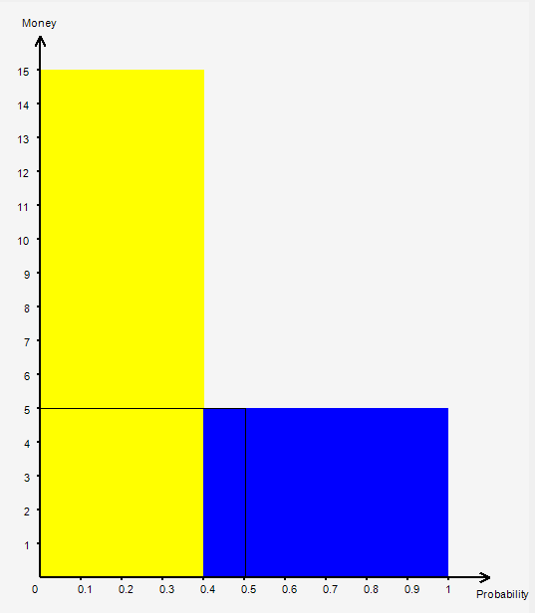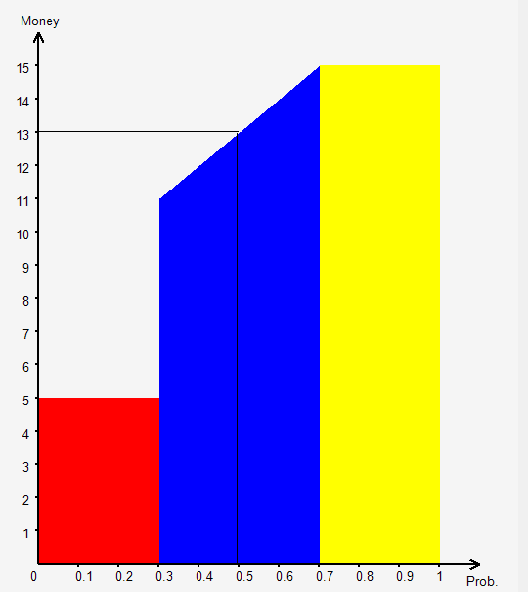

Part 1: Pairwise Choices
Here each problem is a simple pairwise choice as pictured below. In each problem you have to decide which of two lotteries you prefer. If this problem on this part is chosen at random at the end of the experiment, then the lottery that you chose will be the one that is played out.

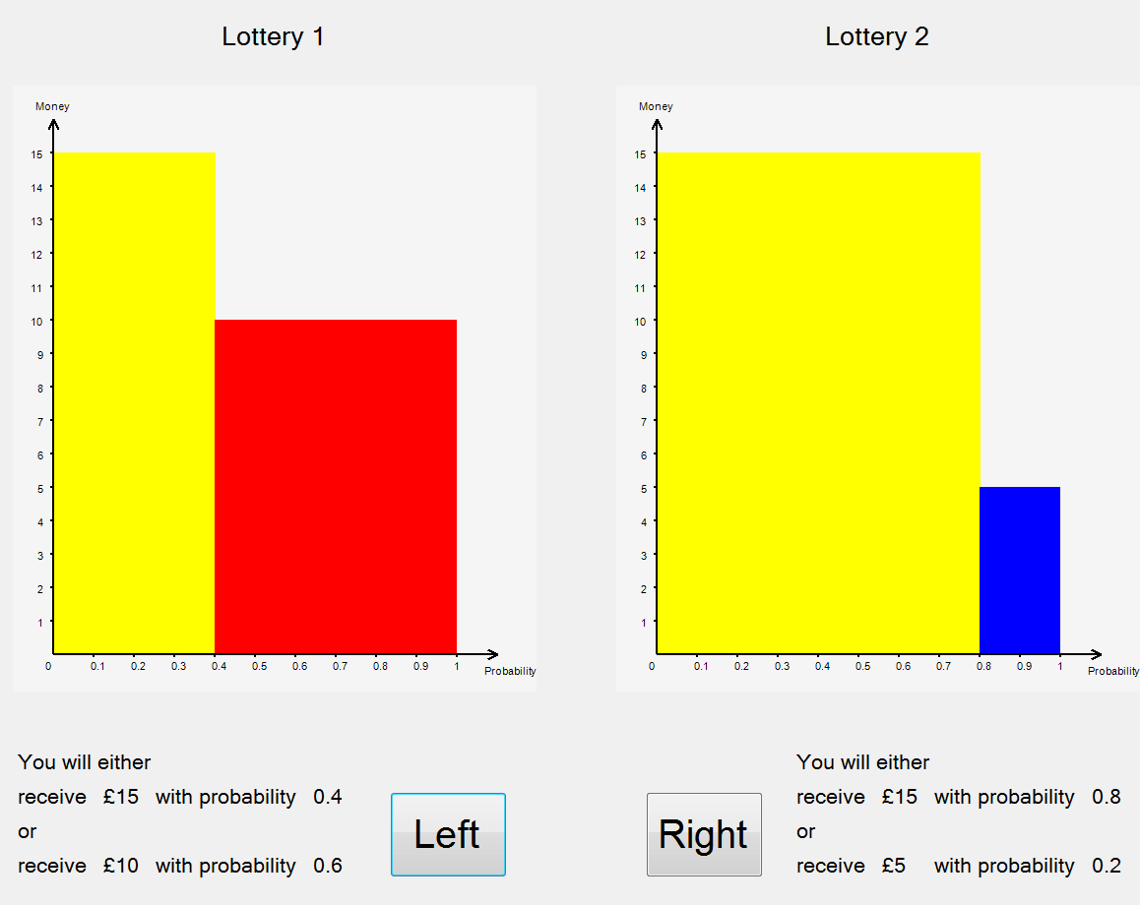
In this case, both lotteries are risky; in some problems one of them may be certain; in some one of the amounts will be £0 and thus not appear in the figure. In the figure we show the amounts of money you might win on the vertical axis and the associated probability on the horizontal. The implications are written in words underneath the figure. So the left-hand lottery would lead to a payoff of £15 with probability 0.4 or a payoff of £10 with probability 0.6; the right-hand lottery would lead to a payoff of £15 with probability 0.8 or a payoff of £5 with probability 0.2; you have to click on the lottery that you would prefer to have played out. In this part you will be asked to express you preferences over a total of 81 such problems.

Part 2: Lists
In some ways this part is similar to Part 2, though here the pairwise choices are structured. Each problem is in the form of a list. One such list is shown in the figure below, which has two sides to it. In each list there is a set of pairwise choice problems, presented in exactly the same way as in Part 1. But, as you will see there is a pattern: one of the two lotteries in any pair is the same throughout the list – here the right-hand ‘lottery’ is always the certainty of £2.50. The other is changing through the list in the sense that the probability of getting the higher amount of money is increasing through the list.

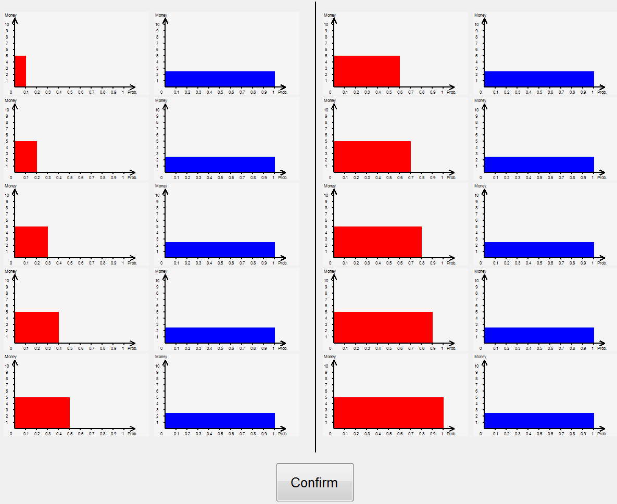
The risky lottery stays unchanged but the certainty increases. In this particular list the right-hand lottery is always the certainty of £2.50, while the left-hand lottery has the chance of getting £5 or of getting £0, with the probability of getting £5 going up from 0.1 to 1.0 through the list. As in Part 1, in each pair you are asked to specify which lottery you prefer. You do this by clicking on the preferred lottery; you will see that when you do this, the other lottery becomes greyed-out. However because one of the lotteries is getting better through the list, we impose some structure on your answers. If you say that you prefer the risky lottery at one point, we force you to say that you also prefer the lottery further down the list. You will understand this as you click through the list. When, in each pair, one of the lotteries has been indicated as preferred by you (and the other in the pair greyed-out) the ‘Confirm’ button will become active, allowing you to record your preferences for that list and move onto to the next list. There are a total of 48 lists in this part of the experiment. Time!

Part 3: Allocations
In each problem in this part, you will be given a sum of money to allocate between two risky events with stated probabilities. One such problem is shown below.
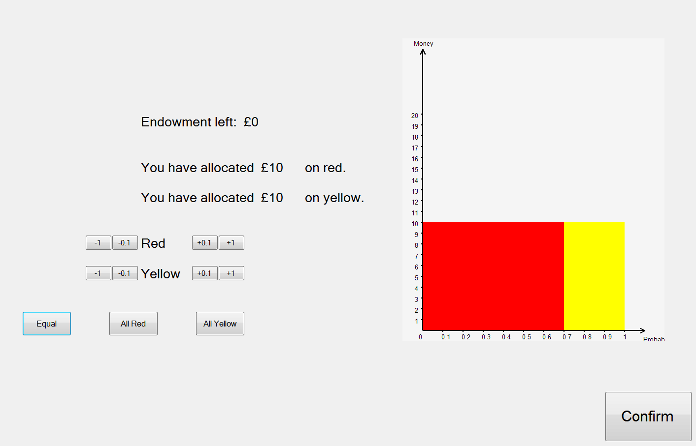
Here there is £20 to allocate; the probability of red happening is 0.6 and that of yellow 0.4. You have to decide how to allocate the £20 between red and yellow; shown is an equal allocation but you may prefer a different one. If this problem were to be played out at the end of the experiment, you will implement a random device, which we will explain later, with chance of 6 in 10 for red to occur and of 4 in 10 yellow. You would be paid the amount of money that you allocated to the colour that was the outcome. There will be a total of 45 problems in this part. Forced to allocate all.

Part 4: Valuations
rewrite 54 problems

